Gallery Page – User Guide

Gallery Page – Public View – Images (Default View)

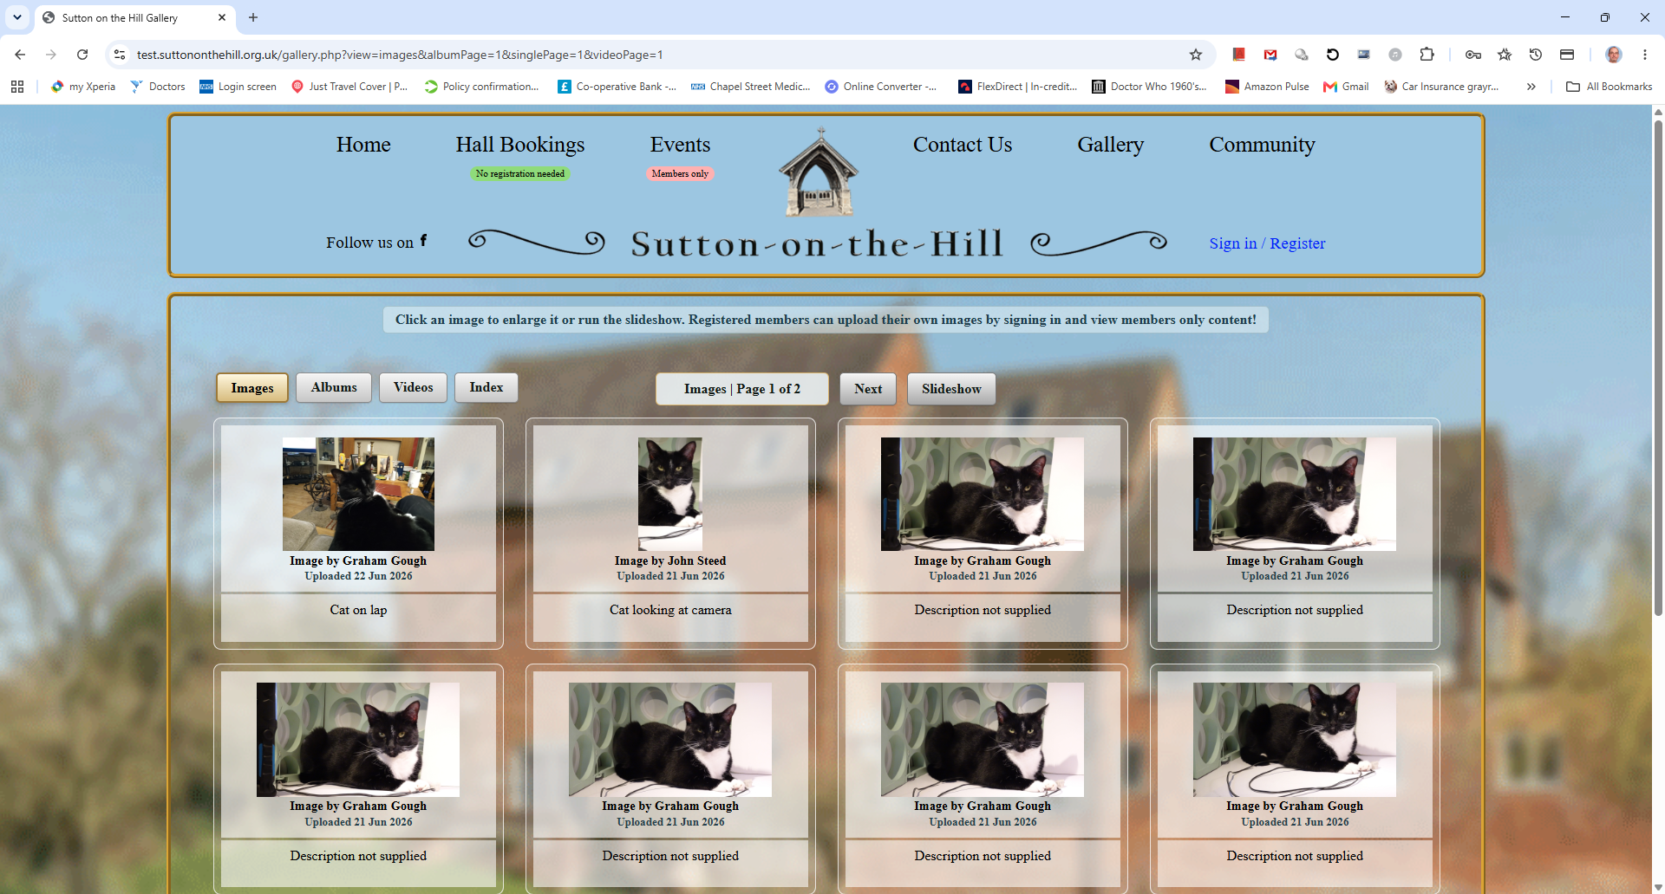
This is the public view of the gallery page when the Images tab is active. It is the default view when the page is loaded. It has a message at the top that says Browse Images, Albums, Videos or the Index. Click any item to enlarge it. Members can upload their own media and view members-only content.
Below that are four tabs Images Albums Videos and Index, followed by, In the middle of this line, the tab name and pagination followed by a Next button and a Slideshow button. The current tab is highlighted (Images) in this case
Images show individual images that have been uploaded showing a thumbnail of the image along with the name of the member who uploaded it, a date and a description. Simply click on an image to enlarge it.
Albums show images that have been uploaded as an album of connected images along with the album title. Individual images of the album show a description of the image. Simply click on an image to enlarge it.
Videos show a thumbnail of videos uploaded along with a name, date and description, and an Open Video button. The videos can be played by clicking on the video control on the thumbnail or for a larger version click on the Open Video button. Videos can be paused using the pause control.
Index will show a popup with a list of searchable media.
Pagination Show the tab name and the page number
Next will take you to the next set of images. It becomes Previous when not on the first page.
Slideshow will launch a popup that allows a slideshow of all the images.
The images are ordered so that latest uploads appear first.

Gallery Page – Public View – Albums
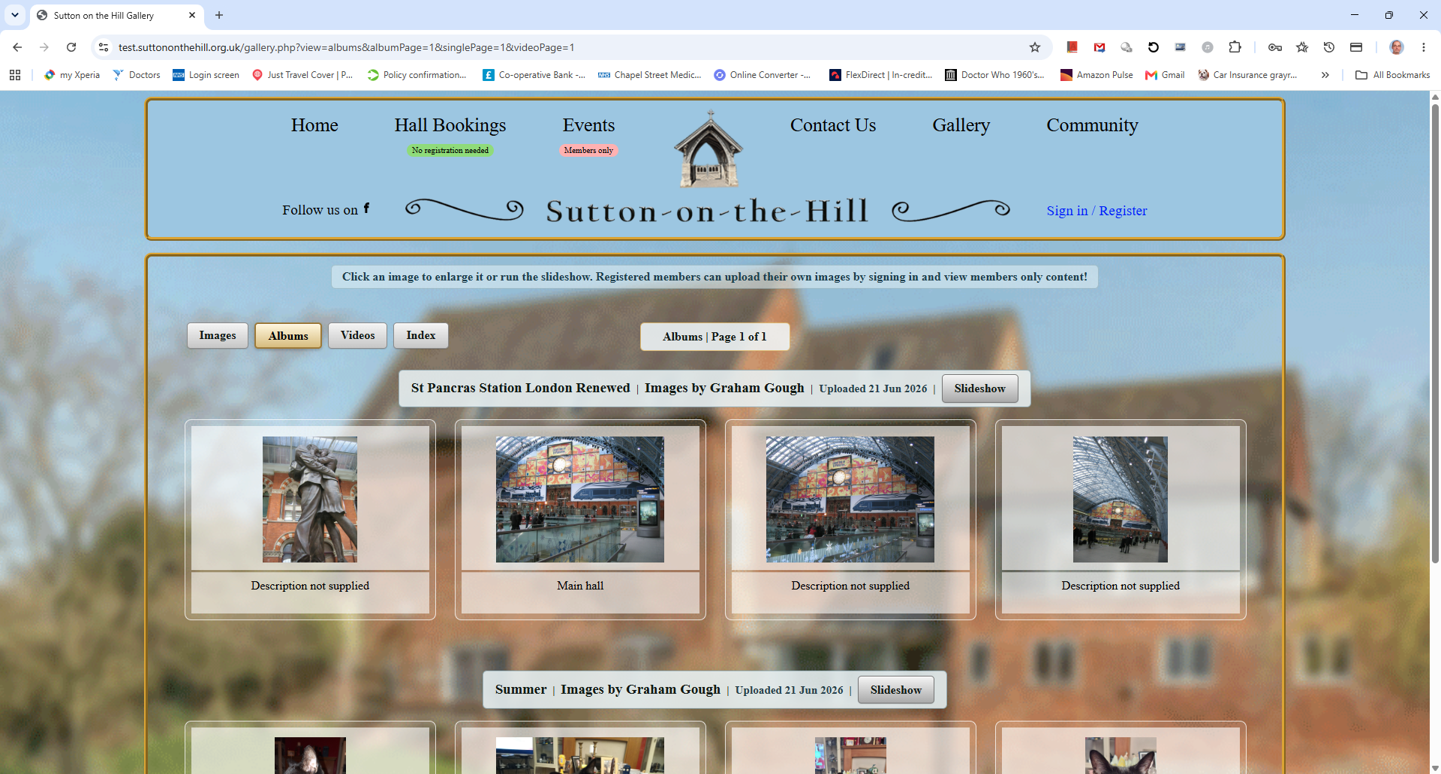
This is the public view of the gallery page when the Albums tab is active.
The current tab is highlighted (Albums) in this case. Below the pagination, for each album are the album title, who uploaded it , a date and a Slideshow button option. Individual images of the album show a description of the image. Simply click on an image to enlarge it or run the slideshow.
The albums are ordered so that latest uploads appear first.

Gallery Page – Public View – Videos
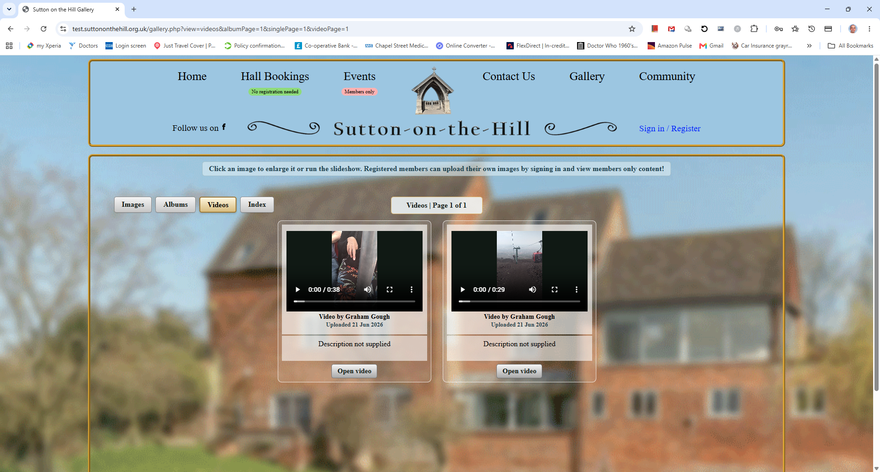
This is the public view of the gallery page when the Videos tab is active.
Each video has a thumbnail of the video along with a name, date and description, and an Open Video button. The videos can be played by clicking on the video control on the thumbnail or for a larger version click on the Open Video button. Videos can be paused using the pause control.
The videos are ordered so that latest uploads appear first.

Gallery Page – Member view
If a member is signed in then they are provided with two buttons to either upload files or access their own file area My Uploads where they can edit previous uploads
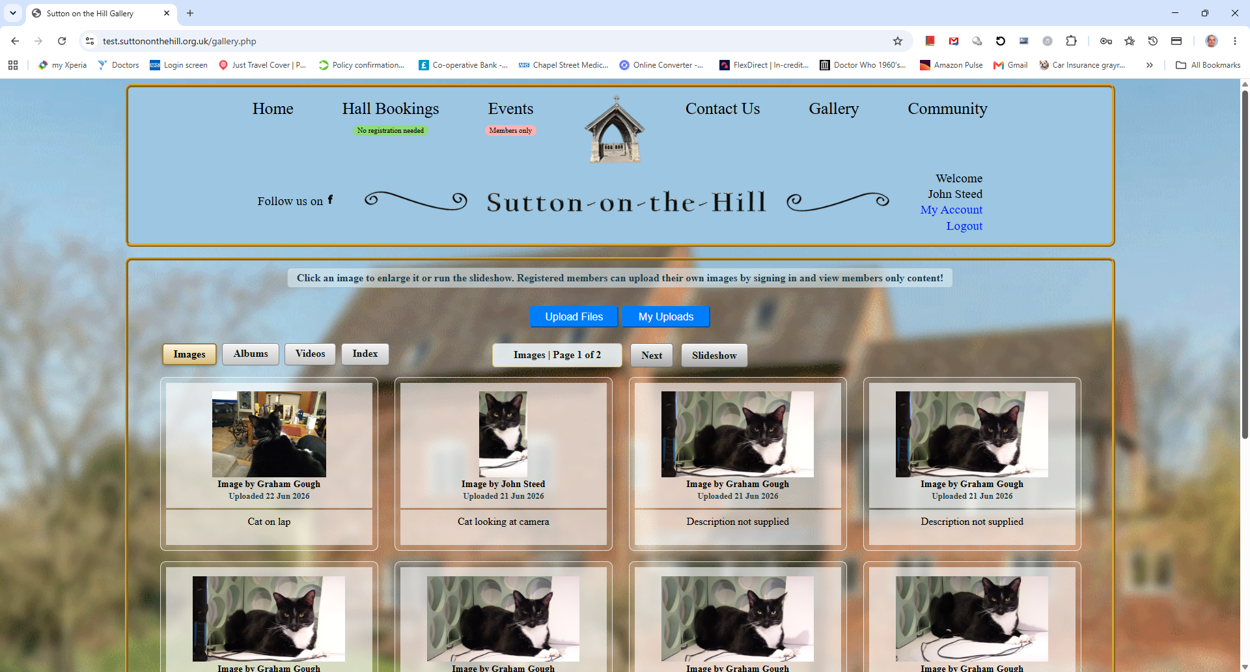
Gallery Page – Member Upload
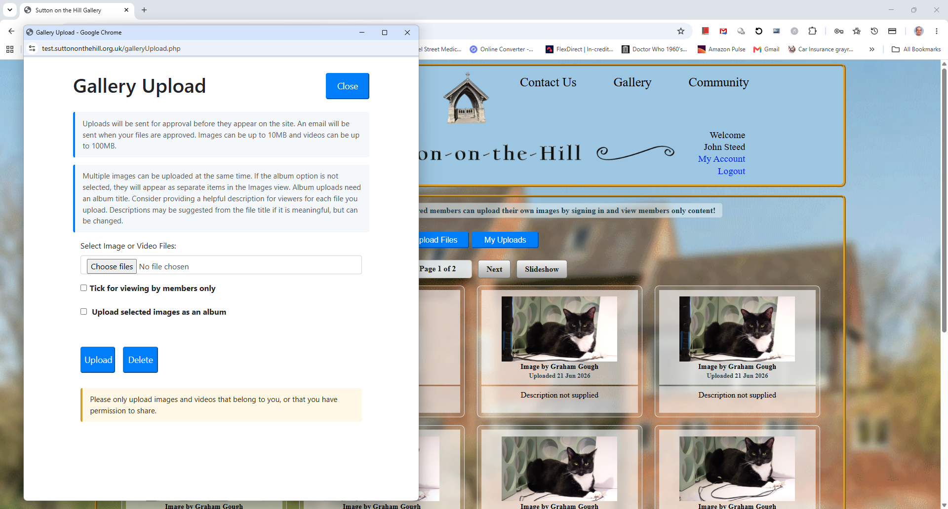
Clicking Upload Files opens the Gallery Upload form, which includes instructions for uploading media and a message to ensure members are aware that uploaded media should be owned by the uploader or the uploader has permission to upload it.
Users can upload a single file or multiple files. They can also choose whether the uploaded media is visible to the public or to members only.
If a user uploads single or multiple unconnected images without checking the album upload check box, the images will appear as separate items in the Images view. Each item can show a credit for the person who uploaded it and an optional description.
If a user uploads videos, the videos will appear in the Videos view. Each video can show a credit for the person who uploaded it and an optional description.
If a user wants to upload multiple related images, they can tick Upload selected images as an album. They will then be asked to enter an album title. The uploaded images will appear together in the Albums view, with the album title and a credit for the person who uploaded them along with the date.
Videos are always treated as standalone items and are not added to albums.
All media uploads are subject to approval and will not appear in the gallery until approved by an admin. An email will be sent to the user when their upload has been approved.
Clicking the check box “Upload selected Images as an album” changes the form as below prompting the user to add an album title which is mandatory.
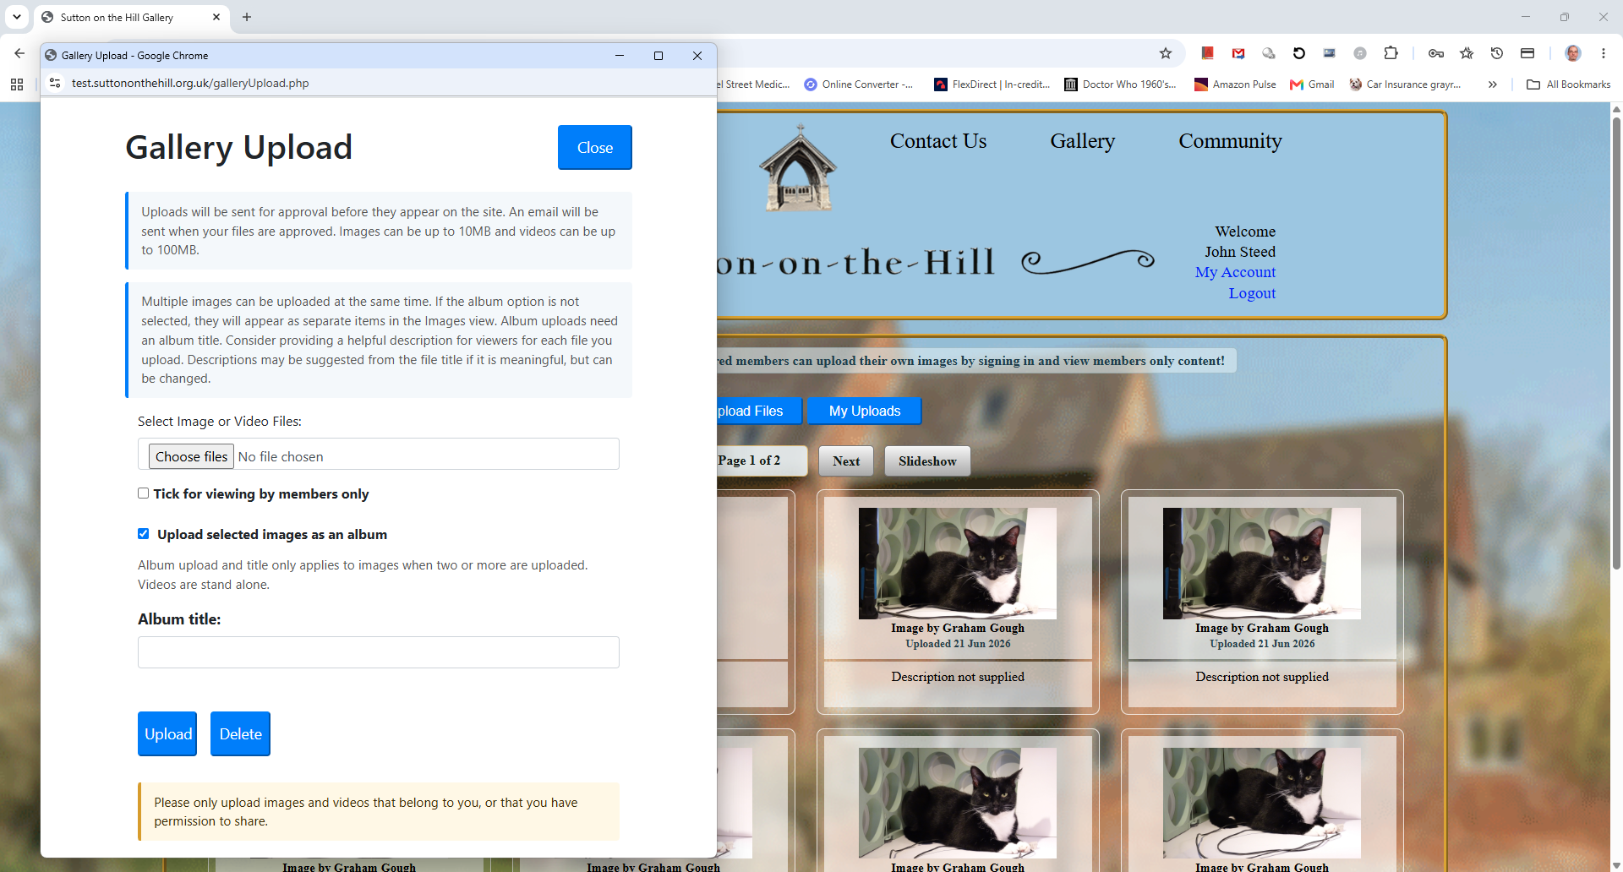

Gallery Page – Selecting media
After clicking on Select or Choose files (Wording is browser dependant) and selecting files they will appear as thumbnails as below. The user must provide an album title and then can optionally add a description of each image. Depending on how the source image file name is constructed the system will try to infer a description, as in the example below, the image is named cat_on_lap.jpg and this is used to generate a description. It can of course be edited. The user has the option of restricting viewing to registered members only. When satisfied with the selection the user clicks upload. The files will be uploaded and a message will appear saying how many files have been submitted and an email will be sent to the admin to approve the submission. If the user wants to start again before submission, then they can delete the files. The window can then be closed using the close button.
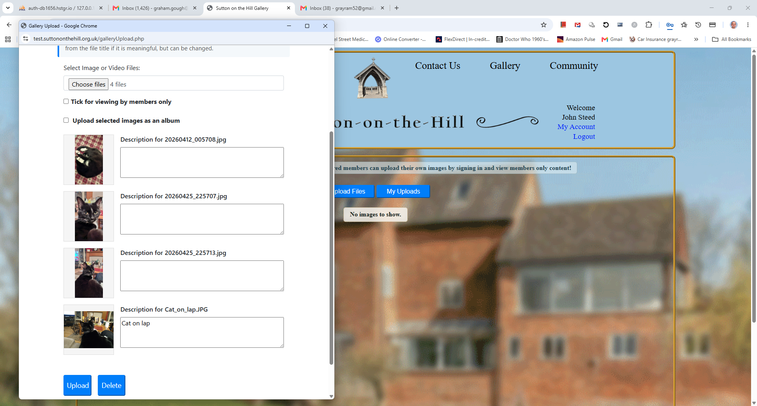

Gallery Page – Slideshow
If a viewer selects slideshow this screen appears that allows for the customary Next, Previous and Play options, Close to return to the gallery
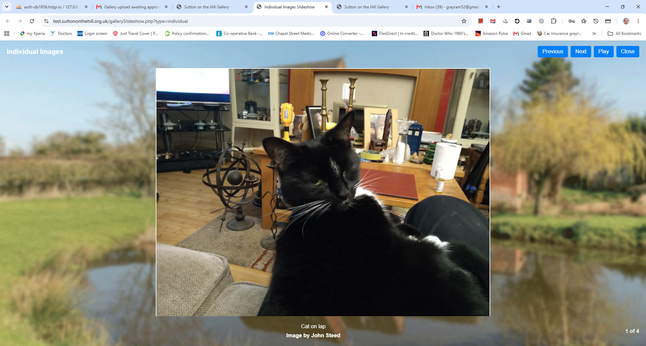

Gallery Page – My Uploads

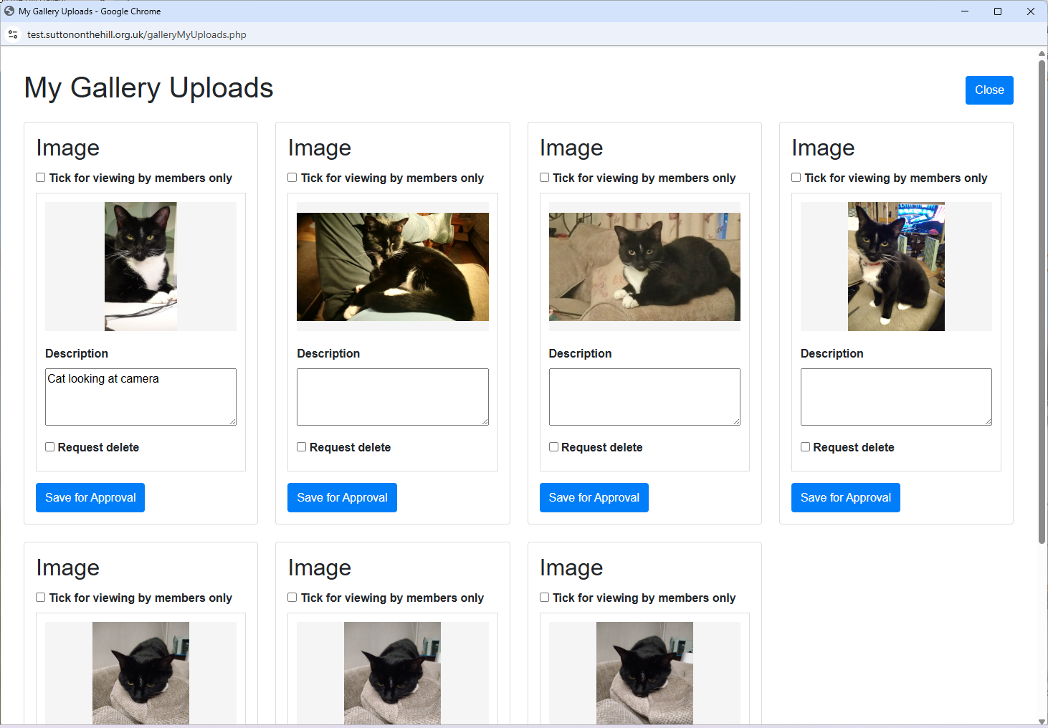
Here the user can make changes to the description of media or request deletion. Changes are notified to the admin and do not change until admin has approved the changes.

